**Else If with Example**

There come situations in real life when we need to make some decisions and based on these decisions, we decide what should we do next. Similar situations arise in programming also where we need to make some decisions and based on these decisions we will execute the next block of code.

For example, in C++ if x occurs then execute y else execute z. There can also be multiple conditions like in C++ if x occurs then execute p, else if condition y occurs execute q, else execute r. This condition of C++ else-if is one of the many ways of importing multiple conditions.

**if-else-if ladder in C++**

a user can decide among multiple options. The C if statements are executed from the top down. As soon as one of the conditions controlling the if is true, the statement associated with that if is executed, and the rest of the C else-if ladder is bypassed. If none of the conditions is true, then the final else statement will be executed.

**Syntax:**

if (condition)

statement;

else if (condition)

statement;

.

.

else

statement;

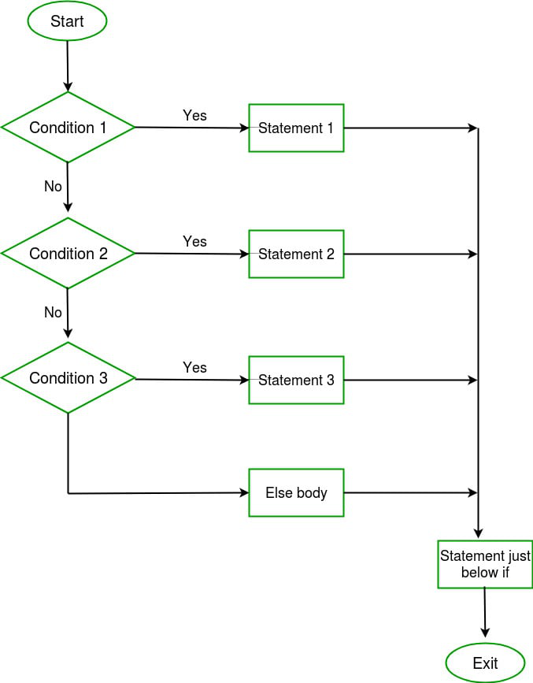

**Example:**

C++

// C++ program to illustrate if-else-if ladder

#include <iostream>

using namespace std;

int main()

{

int i = 20;

if (i == 10)

cout << "i is 10";

else if (i == 15)

cout << "i is 15";

else if (i == 20)

cout << "i is 20";

else

cout << "i is not present";

}

**Output**

i is 20